Processing math: 18%

# **Statistics & Probabilities**

What we will cover today:

0️⃣ Intro  
1️⃣ Descriptive Statistics  
2️⃣ Summary Statistics  
3️⃣ Probabilities  
4️⃣ Random Variables  
5️⃣ Central Limit Theorem

### **Let's start by importing some useful packages**

**import** **numpy** **as** **np**

**import** **pandas** **as** **pd**

**import** **matplotlib.pyplot** **as** **plt**

**import** **seaborn** **as** **sns**

**import** **math**

**import** **scipy**

**import** **scipy.stats** **as** **stats**

# **0️⃣ Introduction**

Quoting [Wikipedia](https://en.wikipedia.org/wiki/Statistics):

Statistics is the discipline that concerns the collection, organization, displaying, analysis, interpretation and presentation of **data**.

Statistics allows to **summarize data** in a small number of indicators

Combined with probability, statisticians can **draw conclusions** 💪 based on **samples** 👌

### **Statistical Work**

* **Data Analysis**: gathering, displaying and summarizing data
* **Probability**: laws of chance, in or out of the casino
* **Inference**: drawing statistical conclusions from specific data, using probability

# **1️⃣ Descriptive Statistics**

* How can we discover **underlying patterns** in a heap of numbers?
* How can we **represent** data in useful ways?
* How can we **summarize** the data?

First step: **gather** some data 🕵️‍♀️

**Experiment**: ask students in a University class to give their **weight** (in pounds).

Male (57)

140 145 160 190 155 165 150 190 195 138 160 155 153 145 170 175 175 170 180

135 170 157 130 185 190 155 170 155 215 150 145 155 155 150 155 150 180 160

135 160 130 155 150 148 155 150 140 180 190 145 150 164 140 142 136 123 155

Female (35)

140 120 130 138 121 116 125 145 150 112 125 130 120 130 131 120 118 125 135

125 118 122 115 102 115 150 110 116 108 95 125 133 110 150 108

We can convert this raw data into a **DataFrame**:

male_df = pd.DataFrame([140, 145, 160, 190, 155, 165, 150, 190, 195, 138, 160, 155, 153, 145, 170, 175, 175, 170, 180, 135, 170, 157, 130, 185, 190, 155, 170, 155, 215, 150, 145, 155, 155, 150, 155, 150, 180, 160, 135, 160, 130, 155, 150, 148, 155, 150, 140, 180, 190, 145, 150, 164, 140, 142, 136, 123, 155],

columns=['weight'])

male_df['sex'] = 'male'

female_df = pd.DataFrame([140, 120, 130, 138, 121, 116, 125, 145, 150, 112, 125, 130, 120, 130, 131, 120, 118, 125, 135, 125, 118, 122, 115, 102, 115, 150, 110, 116, 108, 95, 125, 133, 110, 150, 108],

columns=['weight'])

female_df['sex'] = 'female'

weights_df = pd.concat([male_df, female_df], ignore_index=**True**)

weights_df.sample(5)

|  | **weight** | **sex** |
| --- | --- | --- |
| **49** | 145 | male |
| **39** | 160 | male |
| **25** | 155 | male |
| **75** | 135 | female |
| **33** | 150 | male |

We can now **plot** the data. For every number between 95 and 215, plot a bar chart counting the number of people for a given weight.

ax = sns.histplot(weights_df["weight"], bins=weights_df["weight"].max() - weights_df["weight"].min())

ax.set_xlabel("Weight (in lbs)")

plt.show()

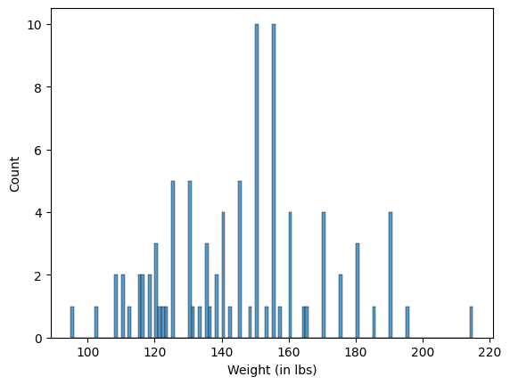

🤔 What's the name of this graph?

### **Histogram**

A histogram is a representation of the **distribution** of **numerical** data.

It is an **estimate of the probability distribution** of a continuous variable.

⚠️ Histogram (continuous variable) ≠ Bar chart (categorical or discrete variable)

### **Histogram Bins**

Instead of drawing one bar per integer in [95,215], we can create **12** bins and count weights falling into these intervals.

f, (ax1, ax2, ax3) = plt.subplots(1, 3, figsize=(15, 4))

ax1.hist(weights_df["weight"], bins=[95, 105, 115, 125, 135, 145, 155, 165, 175, 185, 195, 205, 215])

ax2.hist(weights_df["weight"], bins=12)

sns.histplot(weights_df["weight"], bins=12, ax=ax3, kde=**True**)

plt.show()

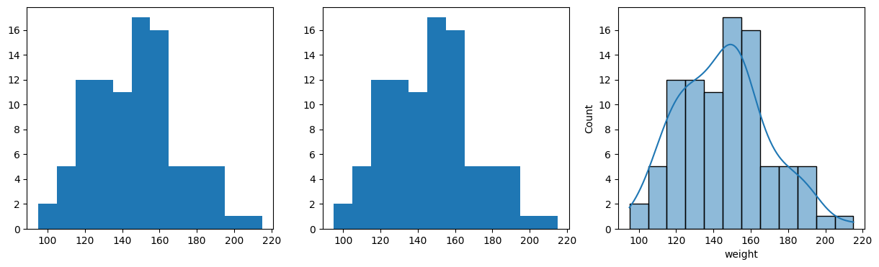

### **Cumulative plots**

Alternatively, we can plot the count of weights *inferior* to a certain value.

Instead of the *counts*, we can also plot the *density* (sums up to 1) or *percentage* (sums up to 100).

f, (ax1, ax2) = plt.subplots(1, 2, figsize=(15, 4))

ax1.hist(weights_df["weight"], bins=25, cumulative=**True**, density=**True**)

sns.histplot(weights_df["weight"], binwidth=5, ax=ax2, kde=**True**,

cumulative=**True**, stat="percent");

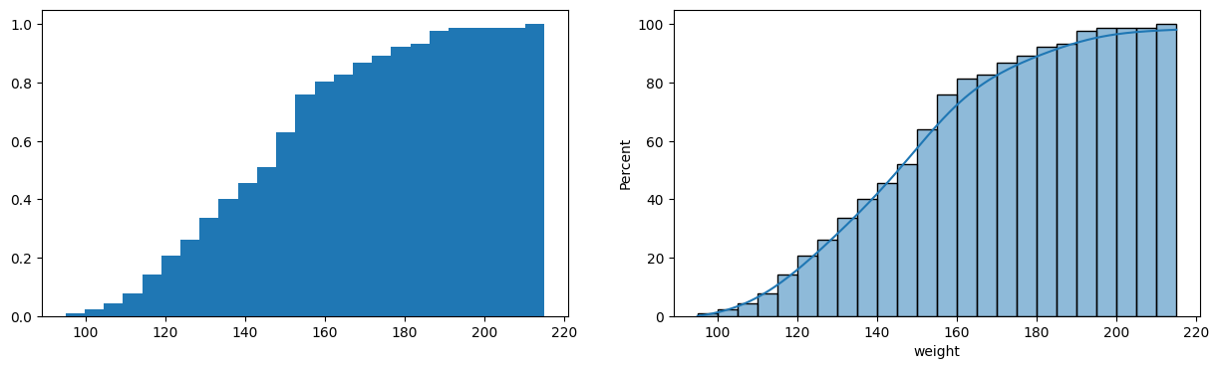

# **2️⃣ Summary statistics**

🎯 Goal: **Summarize** and provide information about the data in a few measures.

Typical summary statistics include measures of:

* Location / central tendency (e.g. **mean**)
* Statistical Dispersion / spread (e.g. **variance**)
* Shape of the distribution (e.g. **skewness** & kurtosis)
* Linear **correlation** of two variables *X* and *Y*

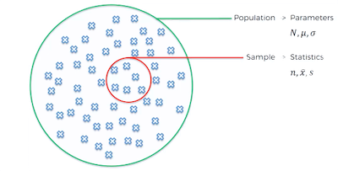

The mean of a **population** of *N* elements is defined by:

*μ*=1*NN*∑*i*=1*xi*=*x*1+*x*2+⋯+*xNN*

The mean of a **sample** of the population *x*1,*x*2,...,*xn* (*n*<*N*) is defined by:

ˉ*x*=1*nn*∑*i*=1*xi*=*x*1+*x*2+⋯+*xnn*

### **Median**

The median is the value **separating** the higher half from the lower half of a data sample

**Odd** number of values:

1 3 3 **6** 7 8 9

**Even** number of values

1 2 3 **4 5** 6 8 9

Then the median is **4.5**

### **Mean vs Median**

Median is robust against outliers.

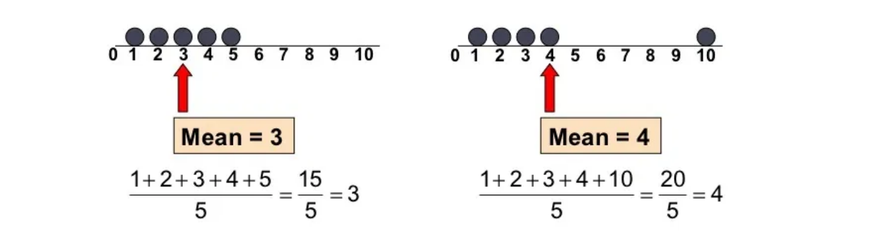

### **Mode**

The mode is the value that appears **most often**

**One mode**

1 3 6 6 6 6 7 7 12 12 17

The mode is **6** and it is unique.

**Bimodal dataset**

1 1 2 4 4

There are two modes: **1** and **4**

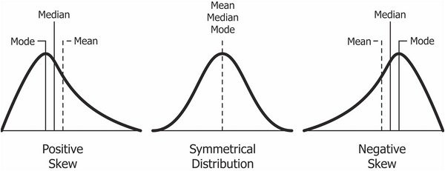

👉 [Skewness](https://en.wikipedia.org/wiki/Skewness) ([*Asymétrie*](https://fr.wikipedia.org/wiki/Asym%C3%A9trie_(statistiques)) 🇫🇷)

### **Statistical dispersion**

Dispersion (also called variability, scatter, or spread) is the extent to which a distribution is stretched or squeezed.

Examples:

* **Variance** *σ*2
* **Standard deviation** *σ* (*Écart-Type* 🇫🇷 )
* Interquatile Range *IQR*
* [etc.](https://en.wikipedia.org/wiki/Statistical_dispersion)

The **variance** of a population of *N* elements is:

*σ*2=1*NN*∑*i*=1(*xi*−*μ*)2

The **standard deviation** of a **population** of *N* elements is the square root of the variance:

*σ*=√1*NN*∑*i*=1(*xi*−*μ*)2

Based on a **sample** of a population, a commonly used estimator of *σ* is the *sample standard deviation*:

*s*=√1*n*−1*n*∑*i*=1(*xi*−ˉ*x*)2

🤔 1*n* would give an underestimate of the true population variance ([Bessel's correction](https://en.wikipedia.org/wiki/Bessel%27s_correction))

### **Interquartile range (IQR)**

The difference between upper and lower quartiles: IQR=*Q*3−*Q*1

💡 It can be used to identify outliers in the data set: they are defined as observations that fall below *Q*1 - 1.5 IQR or above *Q*3 + 1.5 IQR. 📈 IQR is very useful for **boxplots**!

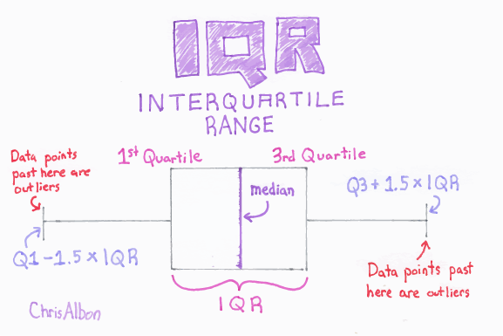

❓ [*But my whiskers are not symmetrical!*](https://stackoverflow.com/questions/51694935/seaborns-boxplot-whiskers-meaning)

### **Summary Statistics**

Summary statistics of a sample are the five following numbers:

* min
* lower quartile (25%)
* median (50%)
* upper quartile (75%)
* max

+ a boxplot

weights_df['weight'].describe()

count 92.000000

mean 145.152174

std 23.739398

min 95.000000

25% 125.000000

50% 145.000000

75% 155.500000

max 215.000000

Name: weight, dtype: float64

sns.boxplot(x=weights_df['weight'])

plt.show()

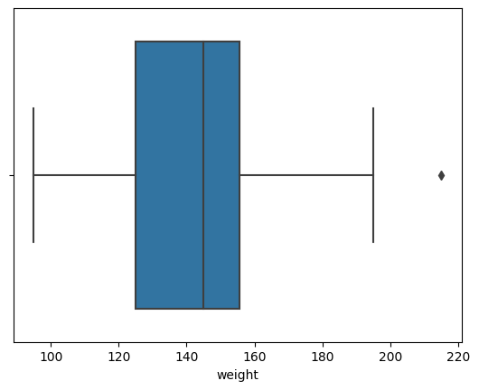

Summary statistics are important, but...

### **⚠️ Beware of the** [**Datasaurus**](https://dl.acm.org/doi/10.1145/3025453.3025912) **🦕**

Summary statistics are not enough, you need to conduct [Exploratory data analysis](https://en.wikipedia.org/wiki/Exploratory_data_analysis) too!



### **Correlation between 2 variables**

The linear correlation between *X* and *Y* is also called the [Pearson's coefficient](https://en.wikipedia.org/wiki/Pearson_correlation_coefficient)

*r*=*Corr*(*X*,*Y*)=*n*∑*i*=1(*xi*−ˉ*x*)(*yi*−ˉ*y*)*nσxσy*

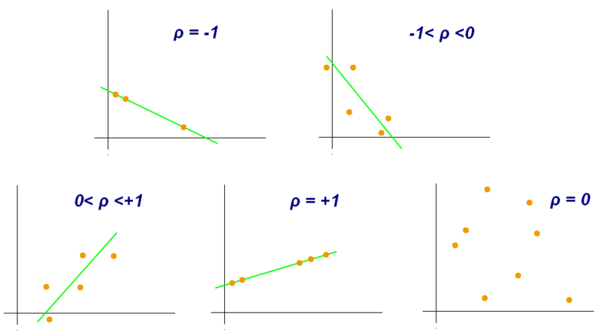

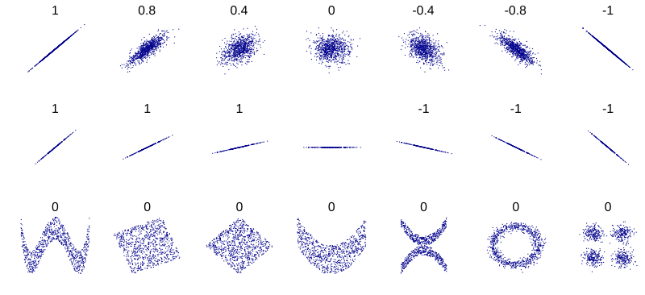

**Correlation vs. Independence?**

* (X,Y) independent ⇒ Corr(X,Y) = 0
* Corr(X,Y) = 0 ⇏ (X,Y) independent (as r only captures **linear** dependence - cf [Wikipedia](https://en.wikipedia.org/wiki/Correlation_and_dependence#Correlation_and_independence))

# **3️⃣ Probabilities**

### **Sets**

Probability theory uses the language of sets. A set is a collection of some items (elements).

Example:

A=\{♣,♢\}

You can perform [operations](https://www.probabilitycourse.com/chapter1/1_2_2_set_operations.php) on sets and visualize them with Venn diagrams:

* Union
* Intersection
* Complement
* Substraction
* Partition

### **Random experiment**

* A random experiment is a process by which we observe something uncertain
* After the experiment, the result of the random experiment is known: it is the (**outcome**)
* The set of all possible outcomes is called the **sample space** S, \Omega \text{ or } U (*Univers*🇫🇷)

Examples:

* Toss a coin. 𝑆=𝐻,𝑇
* Roll a die. 𝑆=1,2,3,4,5,6
* Observe the number of goals in a soccer match. 𝑆=0,1,2,3,\ldots

When we repeat a random experiment several times, we call each one of them a **trial** (épreuve 🇫🇷).

**Sample space** S is defined based on **how you define** the random experiment...

❓ If the experiment is *Toss a coin* ***three*** *times*, what's the sample space?

S=\{ (H,H,H),(H,H,T),(H,T,H),(T,H,H),(H,T,T),(T,H,T),(T,T,H),(T,T,T) \}

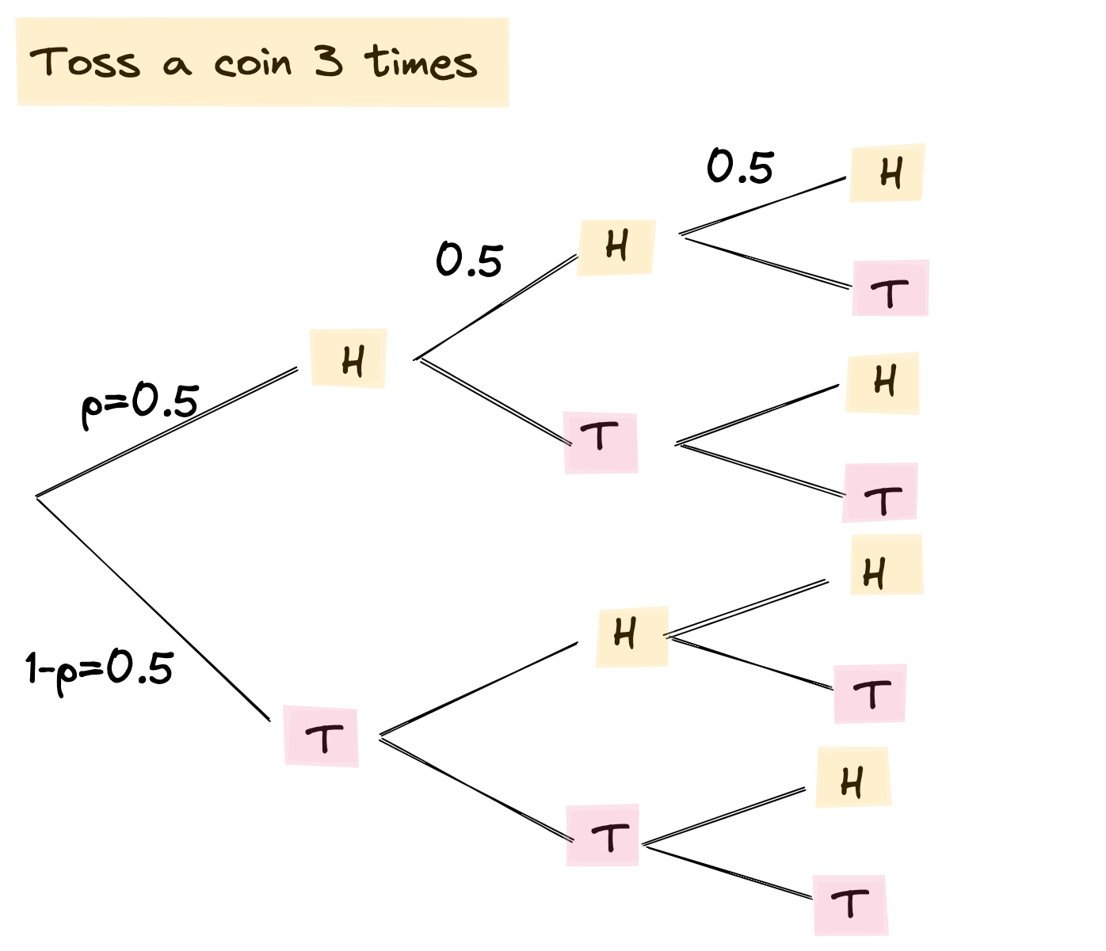

☝️ The goal is to assign a **probability** to events, defined as **subsets** of a sample space S.

### **Probability**

We assign a probability measure P(A) to an event A.

This is a value between 0 and 1 that shows how likely the event is.

### **Union & Intersection**

If A and B are events, then A \cup B and A \cap B are events too.

* \cup - Union occurs iif A **or** B occurs
* \cap - Intersection occurs iif A **and** B occurs

Some properties can be easily visualized with *Venn diagrams*:

P(A^\complement)=1−P(A)

P(A \cup B)=P(A)+P(B)−P(A \cap B)

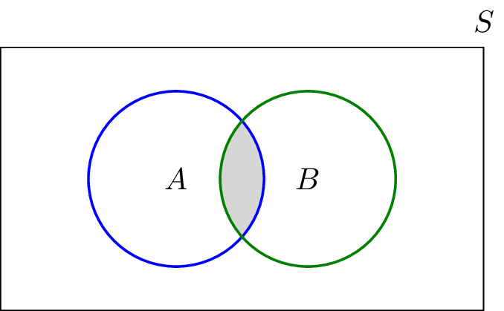

### **Conditional Probability**

As you obtain **additional information**, how would you update probabilities of events?

#### **Defitinion**

Let A and B be two events.

By **definition** (nothing to demonstrate):

P(A \cap B) = P(A)\cdot P(B\mid A)

P(B\mid A) is called the **conditional probability of B given A**, sometimes also noted P_A(B)

#### **👩‍🏫 Example random experiment: Draw two cards, one at a time, without replacement, in a deck of 52 cards.**

You draw the first card: it's a King (event A).

❓ What's the probability that the second card is also a King (event B)?

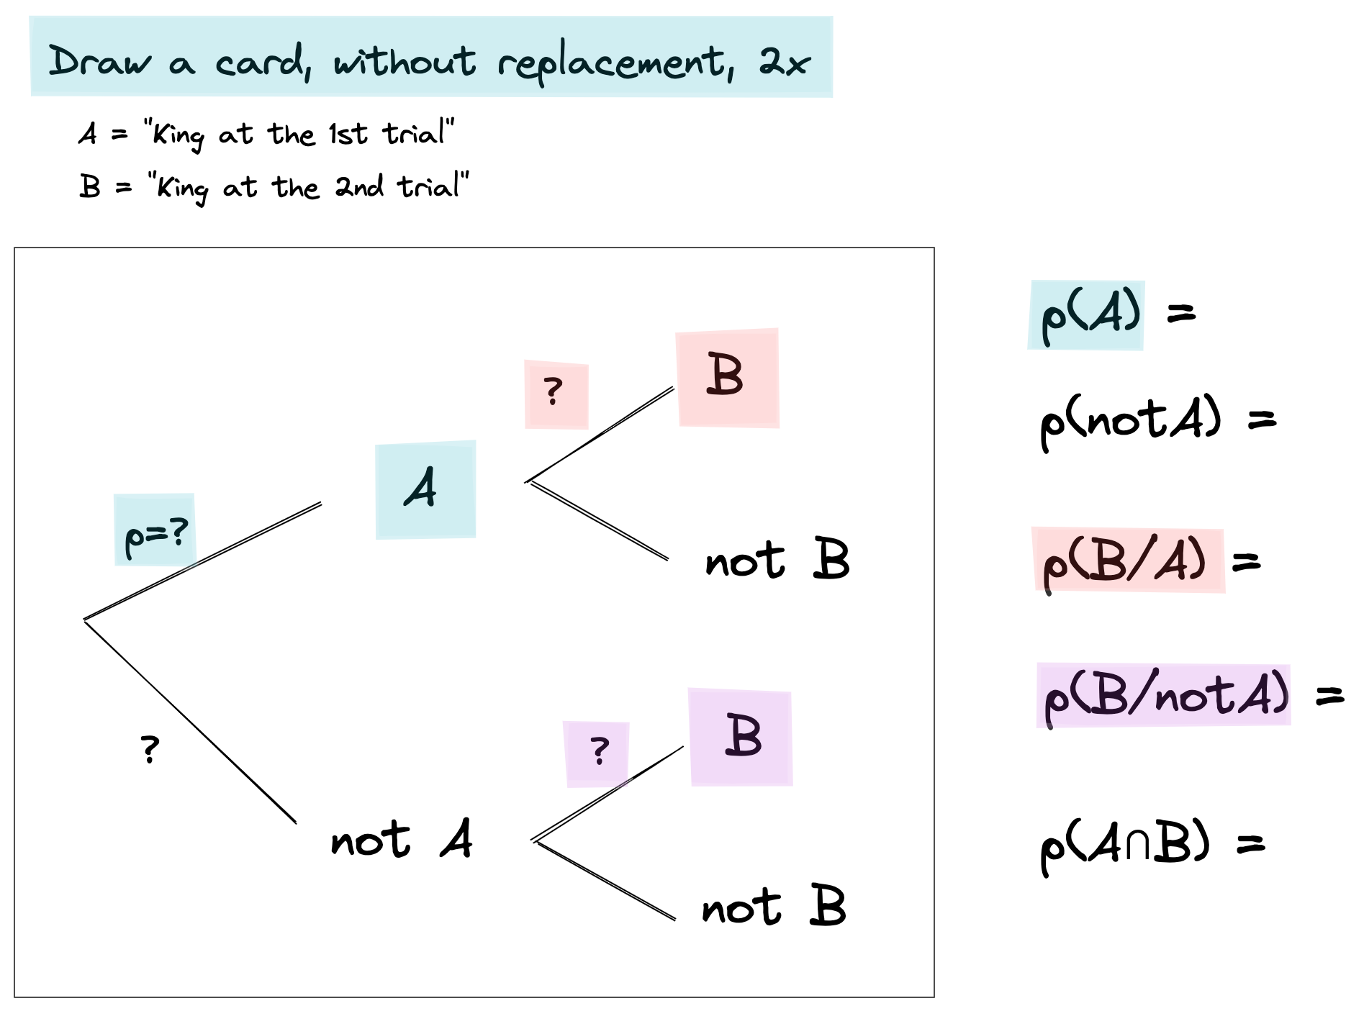

### **Solution**

The first card is not placed back in the deck which means A and B are **dependent**.

P(A) = \frac{4}{52} \approx 0.077

P(B \mid A) = \frac{3}{51} \approx 0.059

P(A \cap B) = P(A) \cdot P(B\mid A) = \frac{1}{221} \approx 0.005

### **Statistical Independence**

Events A and B are independent iif:

P(A\mid B) = P(A)

### [**Bayes' Theorem**](https://en.wikipedia.org/wiki/Bayes%27_theorem)

🤔 Suppose we know P(B \mid A) and we want to compute P(A \mid B)

We know that, *by definition*

P(A \cap B) = P(A) \cdot P(B\mid A) \\ P(B \cap A) = P(B) \cdot P(A\mid B)

With a simple symmetry argument, we have P(A \cap B) = P(B \cap A) so...

🔥 **Bayes Theorem** P(A\mid B)={\frac {P(B\mid A) \cdot P(A)}{P(B)}} for any two events A and B, where P(B) \neq 0:

#### **👩‍🏫 Example - Testing a Disease**

A disease affects about 1 out of 1000 people.

P(Sick) = 0.001

There is a test to check whether the person has the disease and we know that:

The probability that the test result is **positive** (\pmb{+}) given that the person **is sick** is 99% (**true positive**):

P(\pmb{+}\mid S_{ick}) = 0.99

The probability that the test result is **positive** (\pmb{+}) given that the person **is healthy** is 2% (**false positive**): (H_{ealthy} = S_{ick}^\complement)

P(\pmb{+}\mid H_{ealhy}) = P(\pmb{+}\mid S_{ick}^\complement) = 0.02

A random person gets tested for the disease and the result comes back positive 😱.

🤔 What is the probability that the person **actually** has the disease?

P(S_{ick} \mid \pmb{+}) = \text{?}

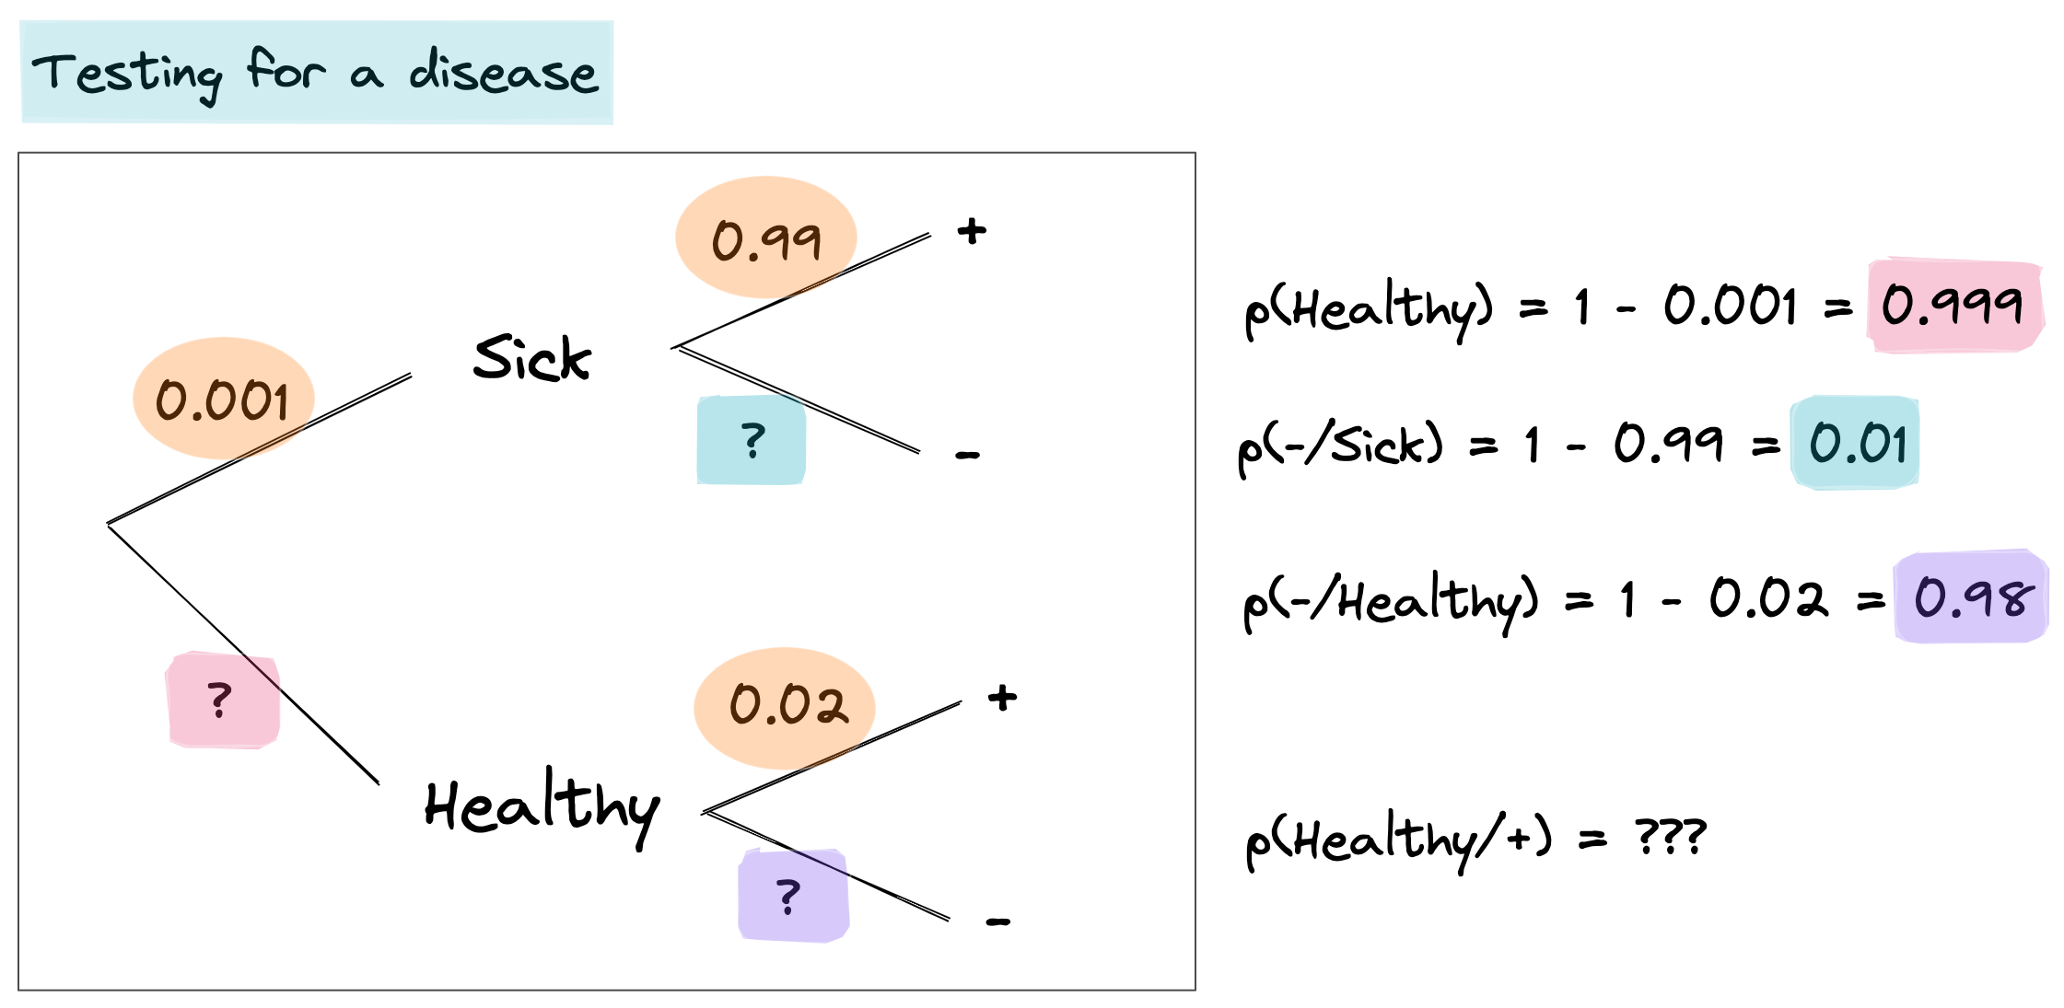

Bayes' theorem can be written as:

P(S_{ick}\mid \pmb{+})={\frac {P(\pmb{+}\mid S_{ick}) \cdot P(S_{ick})}{P(\pmb{+})}}

\begin{align} P(\pmb{+}) &= P(\pmb{+} \cap S_{ick}) + P(\pmb{+} \cap S_{ick}^\complement) \end{align}

\begin{align} P(\pmb{+}) &= P(\pmb{+} \mid S_{ick}) \cdot P(S_{ick}) + P(\pmb{+} \mid H_{ealthy}) \cdot P(H_{ealthy})\\ &= P(\pmb{+} \mid S_{ick}) \cdot P(S_{ick}) + P(\pmb{+} \mid H_{ealthy}) \cdot (1 - P(S_{ick}))\\ &= 0.99 \times 0.001 + 0.02 \times (1 - 0.001) \\ &= 0.02097 \end{align}

We can now compute P(S_{ick} \mid \pmb{+}):

\begin{align} P(S_{ick}\mid \pmb{+}) &={\frac {0.99 \times 0.001}{0.02097}} \\ &\approx 0.047 \end{align}

💡 Less than 5% of people positively tested with test \pmb{+} actually have the disease. This is called the [**false positive paradox**](https://en.wikipedia.org/wiki/Base_rate_fallacy#False_positive_paradox)

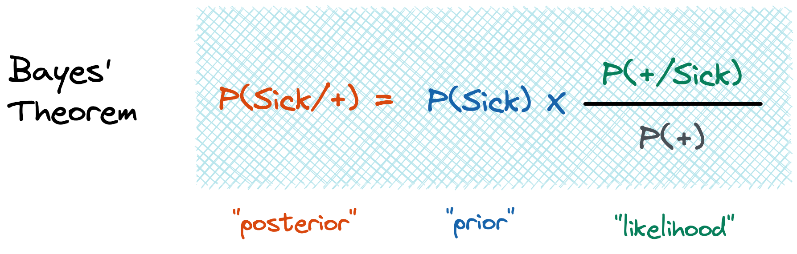

👉 [Bayes Theorem](https://www.youtube.com/watch?v=HZGCoVF3YvM) on Youtube, by 3blue1brown 👌

# **4️⃣ Random variable**

Statistics ❤️ Probabilities

To analyze random experiments, we focus on some **numerical** aspects of the experiment.

For example, in a soccer game we may be interested in the number of goals, shots, etc...

### **Example of a random experiment**

Let's toss a fair coin **twice**.

Sample space is S = \{ (H, H), (H, T), (T, H), (T, T) \}

Let's define the random variable X as the **number of heads**.

### **Definition**

A random variable X is a function from the sample space to the real numbers:

X:S\rightarrow \mathbb{R}

The range of a random variable X, shown by Range(X), is the set of possible values of X.

In our example (X as the **number of heads**):

Range(X) = \{ 0, 1, 2 \}

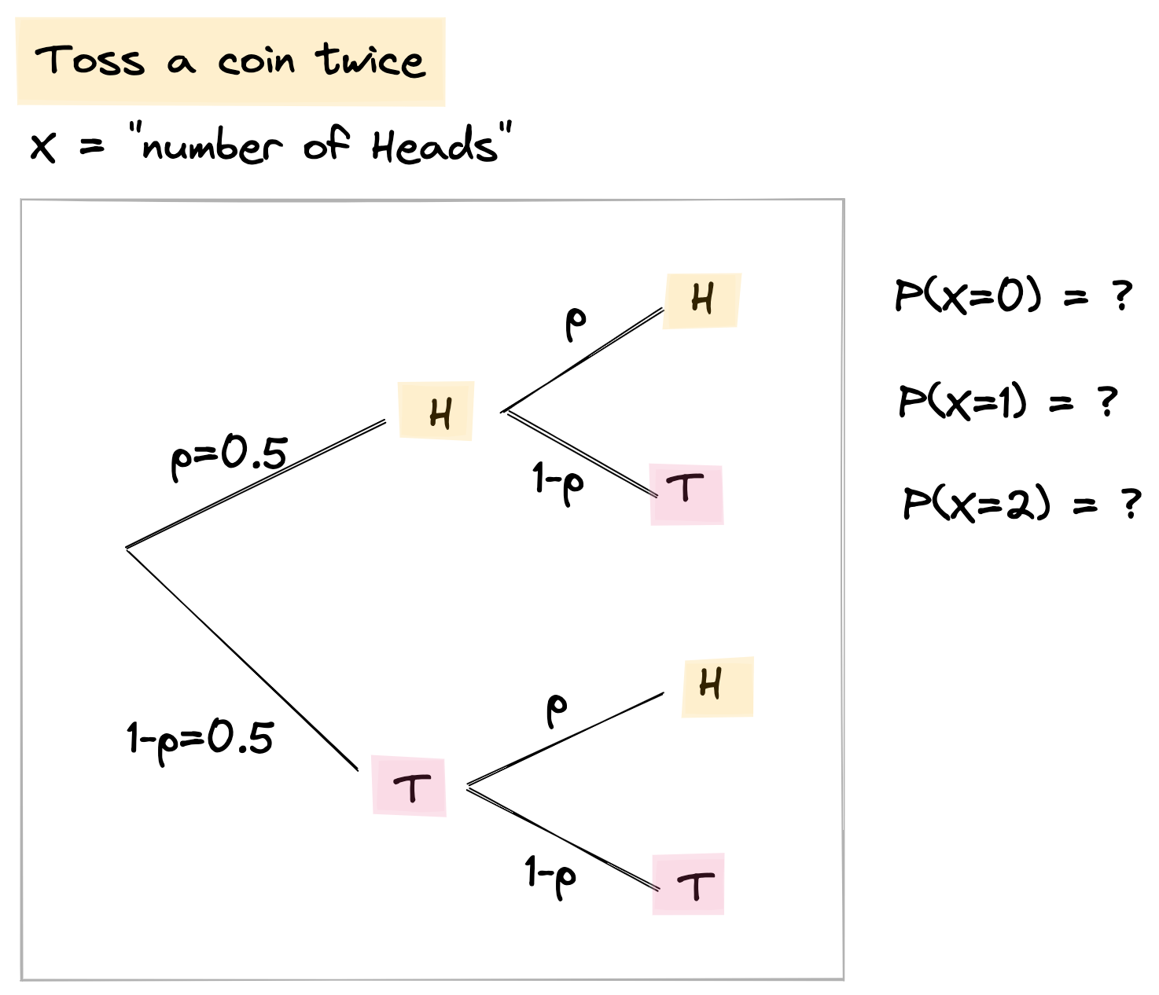

### **Probability Mass Function (**[**PMF**](https://en.wikipedia.org/wiki/Probability_mass_function)**)**

The PMF for X is defined as:

\forall x_i \text{ in } Range(X),\ \text{pmf}_{X}(x_i) = P(X = x_i)

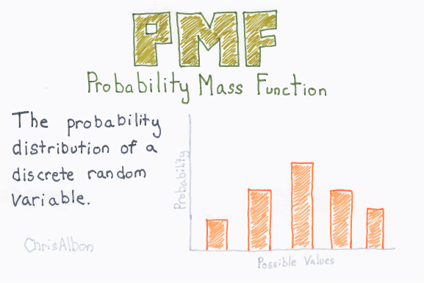

✏️ Let's draw the PMF of X = **"Number of Heads"** for the sample space:

S = \{ (H, H), (H, T), (T, H), (T, T) \}

plt.bar(x=[0,1,2], height=[0.25, 0.5, 0.25], width=0.3);

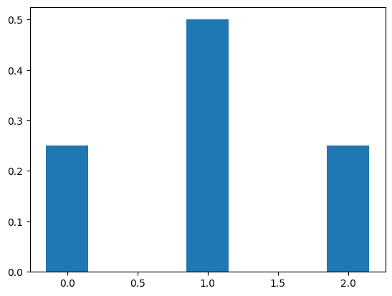

### [**Expected value**](https://en.wikipedia.org/wiki/Expected_value) **E[X]**

Intuitively, a random variable's expected value E[X] represents the **average** of a large number of independent realizations of the random variable X.

X being a **discrete** random value:

{\displaystyle \operatorname {E} [X]=\sum _{i=1}^{n }x_{i}\,p(x_i).}

E[\textit{"Number of heads in 2 tosses"}] = 0*0.25 + 1*0.5 + 2*0.25 = 1

### [**Bernoulli process**](https://en.wikipedia.org/wiki/Bernoulli_process)

Take a random experiment with exactly **two possible outcomes**

and repeat this experiment multiple times

✏️ e.g let's define our Bernoulli experiment as:

toss a coin once

with a proba p = 0.3 of getting 1 (e.g. *Heads*) at each toss

and repeat this experiment a size = 10000 times (large to smooth-out noise)

size = 10000

p = 0.3

np.random.binomial(n=1, p=p, size=size)

array([0, 0, 1, ..., 1, 0, 0])

*# Plot results after 10000 repetitions*

sns.histplot(np.random.binomial(n=1, p=p, size=size), kde=**False**);

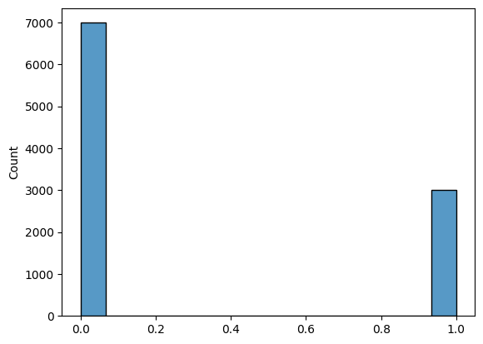

☝️ The associated PMF is called a **Bernoulli Distribution** B(p).

### [**Binomial distribution**](https://en.wikipedia.org/wiki/Binomial_distribution)

🧐 What if we repeat the tossing of the coin n = 5 times and **count the number of heads in the 5 trials** ?

This is called a **Binomial experiment**

n = 5

np.random.binomial(n=n, p=p, size=size)

array([1, 0, 4, ..., 2, 2, 0])

*# Plot results after counting the number of heads ("5 trials")*

n = 5

sns.histplot(np.random.binomial(n=n, p=p, size=size), kde=**False**);

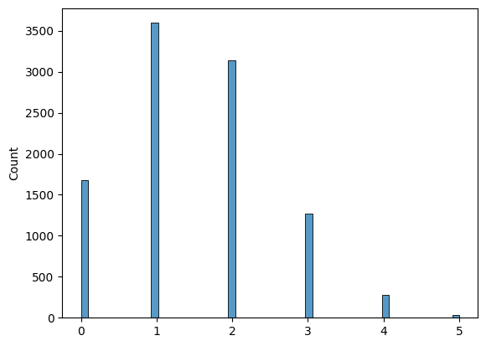

☝️ The **sum** of n **Bernoulli Distributions B(p)** is called a **Binomial Distribution** \mathcal B(n, p).

*# Below is the theoretical "perfect" binomial B(n=5, p=0.3) distribution (obtained if "size" --> infinity)*

n = 5

x = np.arange(n + 1)

pmf = stats.binom.pmf(x, n, p)

plt.vlines(x, 0, pmf, linewidth=10);

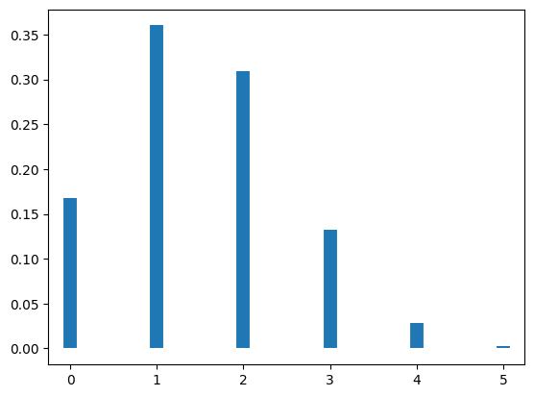

As n increases, **Binomial Distribution** B(n, p) approximates a [normal distribution](https://en.wikipedia.org/wiki/Normal_distribution) \mathcal Ncentered on n*p

n = 100

sns.histplot(np.random.binomial(n=n, p=p, size=size), kde=**False**);

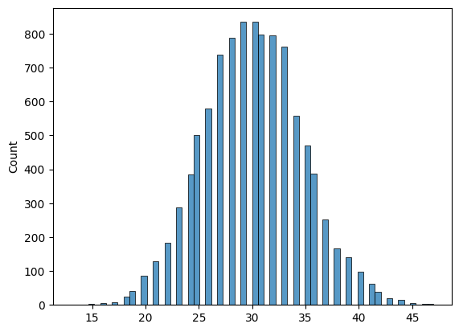

## **🔥 Normal Distribution 🔥**

PDF (Probability Density Function) is:

{\mathcal N(\mu, \sigma) ={\frac {1}{\sqrt {2\pi \sigma ^{2}}}}e^{-{\frac {(x-\mu )^{2}}{2\sigma ^{2}}}}}

**def** plot_normal_distribution(mu, variance):

sigma = math.sqrt(variance)

x = np.linspace(-10, 10, 100)

plt.plot(x, stats.norm.pdf(x, mu, sigma), label=f"μ=**{**mu**}**, σ²=**{**variance**}**")

plot_normal_distribution(0, 1)

plot_normal_distribution(1, 2)

plot_normal_distribution(-3, 5)

plt.legend()

plt.show()

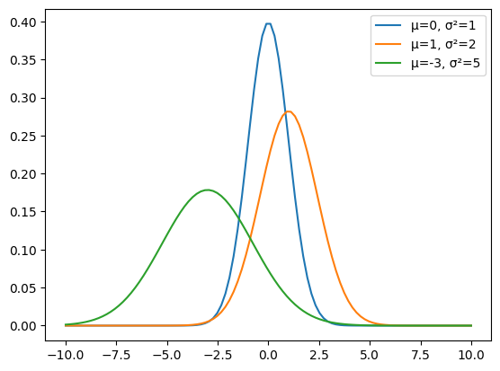

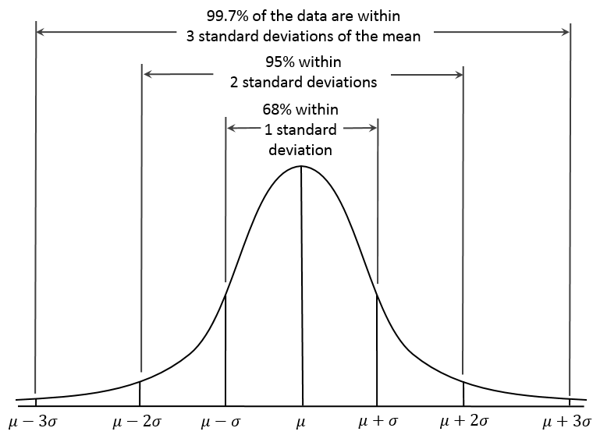

### **PDF vs CDF?**

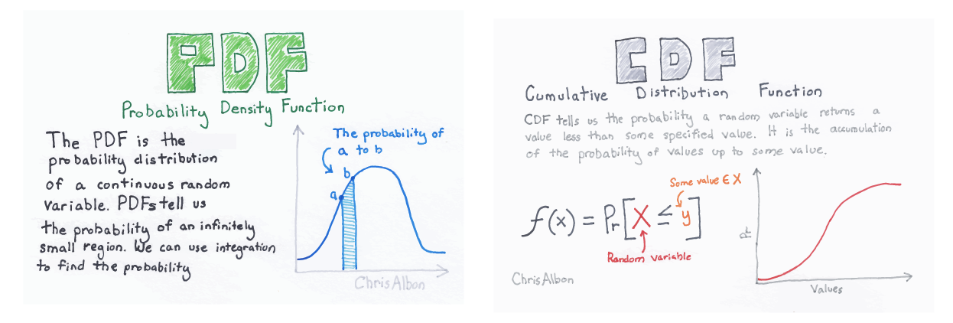

**def** plot_cumulative_normal_distribution(mu, variance):

sigma = math.sqrt(variance)

x = np.linspace(-10, 10, 100)

plt.plot(x, stats.norm.cdf(x, mu, sigma), label=f"μ=**{**mu**}**, σ²=**{**variance**}**")

plot_cumulative_normal_distribution(0, 1)

plot_cumulative_normal_distribution(1, 2)

plot_cumulative_normal_distribution(-3, 5)

plt.legend()

plt.show()

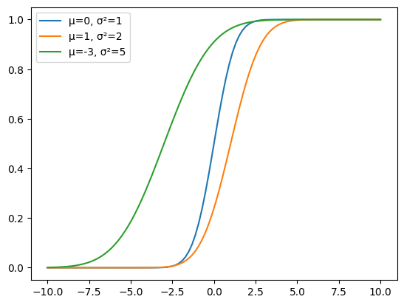

# **5️⃣ Central Limit Theorem 💪**

We will cover the [**Central Limit Theorem**](https://en.wikipedia.org/wiki/Central_limit_theorem) extensively tonight during the RECAP. Here are the main ideas for future reference:

* We saw that the sum/mean of a **Bernoulli process** converges towards a \mathcal Ndistribution
* Actually, this holds true for **any** random process!

When **independent** random variables X_1\dots X_n with **common** probability distribution (with mean \mu and standard devation \sigma) are **added**:

* Their mean \overline X converges towards a normal distribution as the number of samples nincreases
* centered on the common mean \mu
* with standard deviation {\frac{\sigma}{\sqrt n}}

This holds true **whatever** the form of the common distribution is

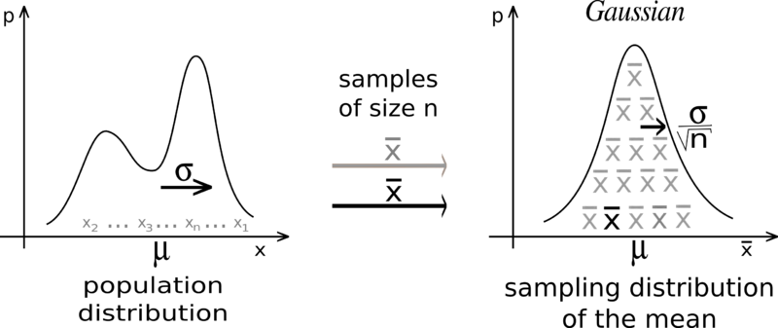

### [**Z-score**](https://en.wikipedia.org/wiki/Standard_score)

If x is an observation derived from a random variable X(\mu,\sigma)

z={x-\mu \over \sigma }

z = value of x expressed in **number of std above/below the mean**

Then CLT can be re-written as:

{\textstyle Z=\left({\frac {{\overline{X}}-\mu }{\sigma /\surd n}}\right)}\to \mathcal N(0,1) \ \text{as } n\to \infty

## **Cheat Sheet**

**Summary statistics**· Mean \mu, Median, Mode  
· Standard deviation \sigma, Variance \sigma^2, IQR  
· Correlation r = Corr(X,Y)

**Probability**· Conditional probability P(B|A)  
· Independence P(B|A) = P(B)  
· Bayes Theorem P(B|A) = P(A|B) {\frac {P(B)}{P(A)}}

**Random variables** X (numerical outcome of a random experiment)  
**Random process** (repeated sequence of random variable trials)

**Distribution of probability**· Binomial \mathcal B(n, p) from Bernoulli (0/1) processes  
· Normal \mathcal N(\mu, \sigma^2) from sum of [idd random variables](https://en.wikipedia.org/wiki/Independent_and_identically_distributed_random_variables)

**Central Limit Theorem**· \ \overline{X} = {\frac{X_1+...+X_n}{n}} \xrightarrow[n \to \infty]{} \mathcal N(\mu,{(\frac{\sigma}{\surd n})^2}) \   
· {\ \textstyle Z=\left({\frac {{\overline{X}}-\mu }{\sigma /\surd n}}\right)} \xrightarrow[n \to \infty]{} \mathcal N(0,1) \

## **Going Further**

Statistics:

* [Sensitivity & Specificity](https://en.wikipedia.org/wiki/Sensitivity_and_specificity)
* [Central Limit Theorem](https://en.wikipedia.org/wiki/Central_limit_theorem)
* [Skew and Kurtosis](https://codeburst.io/2-important-statistics-terms-you-need-to-know-in-data-science-skewness-and-kurtosis-388fef94eeaa)
* [Sampling & Statistical Inference](https://www.probabilitycourse.com/chapter8/8_1_0_intro.php)
* [Confidence Interval](https://en.wikipedia.org/wiki/Confidence_interval)
* [Simpsons' Paradox](https://en.wikipedia.org/wiki/Simpson%27s_paradox)
* [Bootstrapping](https://en.wikipedia.org/wiki/Bootstrapping_%28statistics%29)

Probabilities

* [Probability Mass & Density Functions](https://hadrienj.github.io/posts/Probability-Mass-and-Density-Functions/) (Hadrien Jean 🙌)
* [Marginal & Conditional Probabilities](https://hadrienj.github.io/posts/Marginal-and-Conditional-Probability/) (🙌)
* 📺 [3Blue1Brown - Central Limit Theorem - Inutuitive understanding](https://www.youtube.com/watch?v=zeJD6dqJ5lo)
* 📺 [3Blue1Brown - Bayes Theorem - Inutuitive understanding](https://www.youtube.com/watch?v=HZGCoVF3YvM)

## **Your turn!**